Lab6 Basic Shell Scripts
- Objective
- Capable of creating and executing shell script
- Master basic syntaxes of shell script
- Capable of using shell script to finish tasks
- Lab Environment
- Recommended: Ubuntu Desktop 24.04
- The other Linux or Unix-like environment
- Instructions
- Login to the account of your student id. Use screenshot to show that you finish a specific task by paste it right below the tasks (The screenshot should contain your student id).
- Write answers to the questions related to each task right below the question.
- Once you finished, you should rename the current file name “Linux2026_lab6_STUID.docx” (STUID should be changed to your own student id) and then submit it to the Chaoxing system before 7th May.
- Tasks
- Create a shell script called profile.sh. The script should interactively ask the user for their Student ID and their Favorite Programming Language.
1) The script should display prompts like: "Please enter your Student ID: " and "What is your favorite programming language?"

read -p "Please enter your Student ID: " STUDENT_ID
read -p "What is your favorite programming language? " LANGUAGE

2) After receiving the input, it must output a summary sentence exactly in this format on the screen:
"Profile generated! User Student_ID prefers coding in Language."
echo "Profile generated! User ${STUDENT_ID} prefers coding in ${LANGUAGE}."

3) The script must also automatically create a text file named after the student's ID (e.g., Student_ID.txt). Inside this file, write the following content:
Student ID: Student_ID
Favorite Language: Language
cat << EOF > "${STUDENT_ID}.txt"
Student ID: ${STUDENT_ID}
Favorite Language: ${LANGUAGE}
EOF

4) Run your script using two different methods discussed in the lecture and explain the differences.
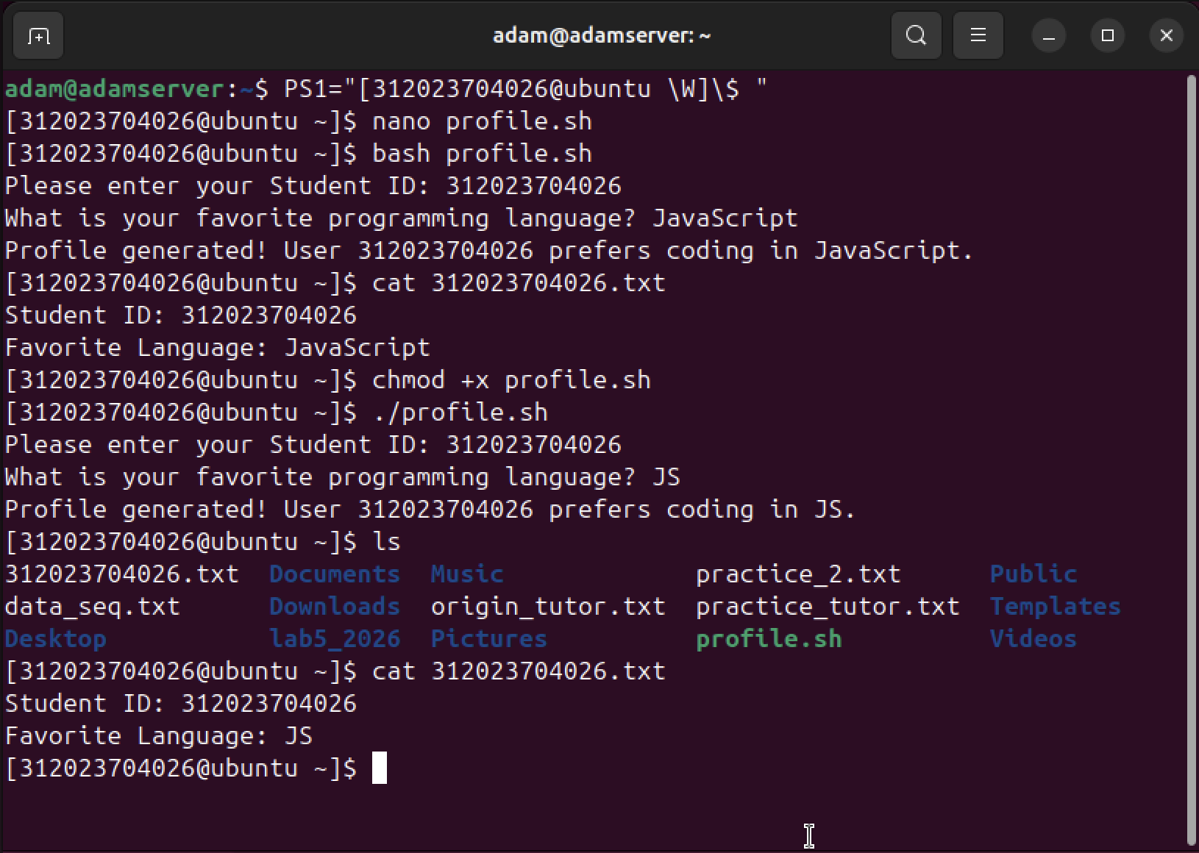
Method 1: Invoking the Interpreter (bash profile.sh)
- Mechanism: This approach involves explicitly calling the Bash shell to process and execute the commands contained within profile.sh.
- Access Rights: Only read access is required for the script file. Since the interpreter handles execution, the file itself does not need executable status.
Method 2: Direct Script Execution (./profile.sh)
- Mechanism: The script is treated as a standalone binary. Utilizing ./ instructs the system to locate the executable within the local directory.
- Access Rights: This necessitates execute privileges, typically granted via chmod +x profile.sh. The operating system restricts direct running without these permissions.

- Write a shell script called dir_analyzer.sh that takes a directory path as a positional argument. The script must scan that specific directory and count four distinct types of items: Regular Files, Directories, Hidden Files, and Symbolic Links.
1) Example Output Format:
Directory Analysis: /etc
Regular Files: 87
Directories: 139
Hidden Files: 3
Symbolic Links: 7
2) Execution: Use your script to analyze and compare the results of two system directories: /etc and ~.
(Hint: You will need to use ls -l combined with grep and wc -l)

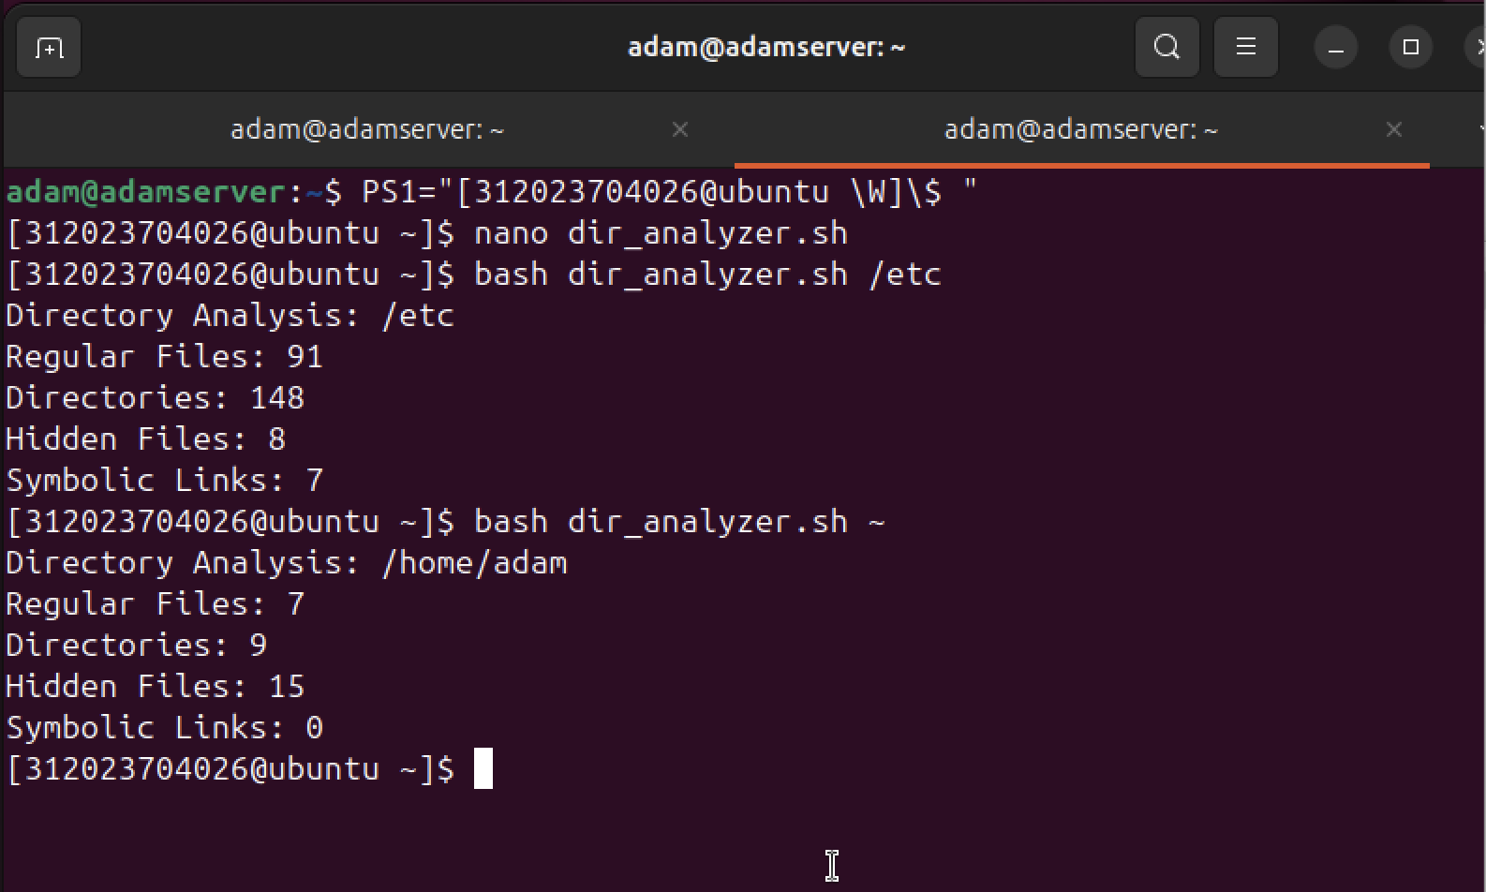
Observations:
- The /etc directory contains significantly more regular files and sub-directories because it is a central location for system-wide configuration files.
- My home directory (~) has more hidden files, which is common as Linux stores user-specific application settings and shell history in hidden "dot files".
- There are no symbolic links in my current home directory, whereas /etc uses them to point to various system resources.

- Write a shell script called cylinder_vol.sh that calculates the volume of a cylinder.
1) The script should prompt the user to input the radius of the base and the height of the cylinder.
2) Use the constant π ≈ 3.14159. The formula for the volume is: $V=πr^{2}h$.
